Name: Furqan Ahmad
Registration No: 8297
Assignment No: 04
Submitted To: Ma’am Sadaf Tanvir

Assignment:

- The product has been successfully published on gumroad:

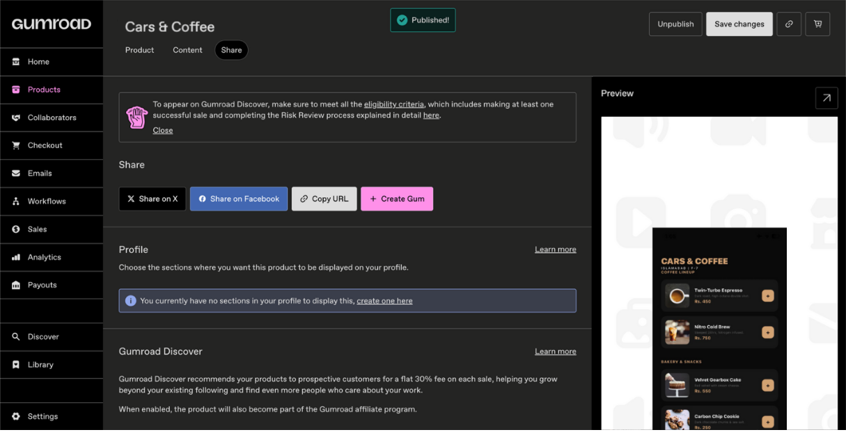

- The midterm mobile application has been successfully uploaded and launched on the Gumroad platform.
- The listing is now live and publicly accessible, as confirmed by its "Published" status.
- This milestone marks the successful deployment of the application within a professional digital marketplace.

- Payoneer has been successfully integrated as a payment option:

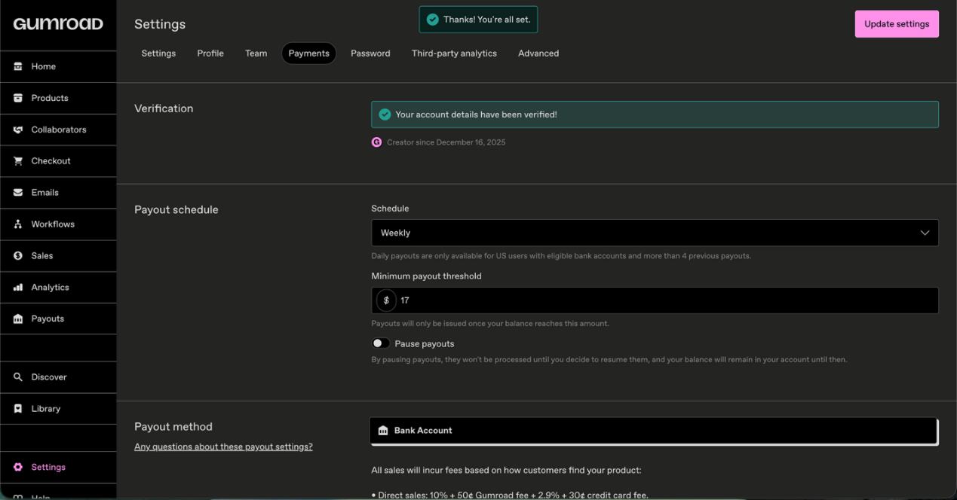

- Payment configurations have been successfully verified on the Gumroad platform.
- The account status confirms that payouts are fully enabled, ensuring the system is ready to process transactions.
- Revenue generated from sales will be automatically disbursed to the linked bank account in accordance with Gumroad standard payout schedule.

- Proof of Published:
